Jack Seagrist

CEE 263C

11/19/2020

## Evaluating Wind Energy Potential in Northern California

## Introduction

Global warming is a serious threat to the well-being of future generations and their ability to interact with this planet. While there are many industries that need to change protocols to help combat climate change, one of the most critical is the energy sector. Electricity has allowed us to develop incredible technology and connect us across the globe. However, it is also a large contributor to greenhouse gas emissions. According to a study conducted by the EPA in 2018, electricity production produced 26.9 of total US greenhouse gases.1 [1] As a result, renewable energy has a large part to play in reducing this number.

There are many types of renewable energy, one being wind power. Wind power is generated by using large turbines to harness the kinetic energy of wind. Wind causes large turbines hooked up to generators to rotate and produce electricity. These turbines can be very large, standing over 80 meters high.2 [2] Generally these turbines are built in wind farms, which contain a large number of turbines close together.

The goal of this paper will be to look at wind power generation in California and factors affecting wind energy production. First an overview of wind power systems and wind power in California is given. The section after will describe the methods and data used in the analysis. Finally the results from the analysis and future work will be provided.

## Wind Power

### Winds

From class we learned about the many different types of winds and the forces that cause them. The four main types of wind are: geostrophic, gradient, surface along straight isobars, and surface along curved isobars. Each of these winds has a different combination of forces driving it. For example, geostrophic wind is created from the coriolis and pressure gradient force, whereas surface winds acting along circular isobars have the coriolis, pressure gradient, friction, and apparent centrifugal force acting. This provides an explanation for the horizontal movement of wind, but there is also vertical movement in our atmosphere. Vertical movement occurs around high and low pressure centers. Low pressure centers typically have isobars that are closer together, and as a result stronger wind due to the pressure gradient force. In the northern hemisphere, as the wind travels counterclockwise around the surface low, the friction force causes convergence where all of the air travels towards the center. This causes air to rise, forming clouds. Air travels clockwise around surface high pressure centers in the northern hemisphere and causes divergence, or air from above to sink. These are the main mechanisms for air to travel vertically.

Combining these mechanics allows you to understand the different types of winds generated in the atmosphere. The topography of an area plays a role in the wind generated for that region. In northern California, specifically the San Francisco bay area, the terrain is mountainous and located close to the sea. Near the sea, when the land is warmer during the day you can get a land breeze, where the wind blows from the land to the ocean. Conversely, at night when the land is colder you can get a bay breeze, where the wind blows from the bay onto land. Pressure and temperature play a big role in wind formation in the atmosphere. The figure A1 in the appendix shows a map of the annual average wind speed at 30m created by the wind exchange.

### Wind Power Mechanics

As mentioned previously, wind power is generated by wind turbines. There are two major types of wind turbines: vertical axis and horizontal axis. Vertical axis wind turbines have their axis perpendicular to the wind stream, while horizontal axis turbines axis’s are parallel to the wind stream. In general, the majority of wind turbines in production are horizontal axis.[3]

Taking a closer look at the mechanics of horizontal axis turbine power generation, these structures harness the energy from wind via large propeller-like blades. Often there are three steel blades mounted to a large tower up to 80 meters high, taking advantage of the faster wind speeds at higher altitudes.[4] Wind blowing across the turbine causes low-pressure on one side of the blade, causing lift which rotates the blades. Due to the large inertial mass of the propeller blades, the shaft typically has a rotational speed of 5-20 rpms. To produce AC electricity, the shaft of the propeller blades is connected to a gearbox which increases the rotational speed up to 1800 rpm.

There are many factors that affect the operating capacity of wind turbines. A study conducted by El-Ahmar et. al (2017) investigated the most critical factors for wind power generation and devised the following list: wind speed, air density, rotor sweep area, and tower height.[5] Each of these components influences the power output differently. Power generation is directly related to wind speed, where larger wind speeds produce larger power output. In fact, power is often estimated with the equation presented below.

Fig 1 - Wind Power Equation[6]

Air density, which is a function of air pressure and temperature, impacts the power output of a turbine. El-Ahmar et. al (2017) show that power generation decreases as air density decreases. Additionally, rotor swept area is directly proportional to the power generation, where the larger the area the larger the power output.

### California Wind Power

In California, wind power is playing an increasingly significant role in the switch to renewable energy sources. In 2018, California wind projects generated 15,078 gigawatt-hours of electricity which accounted for 7.2% of all power generated.[7] If you account for imports, 11.5% of California’s total power consumption could be attributed to wind generation.8

## Data Sources

The main sources of data for this project involve climate information and wind power generation statistics. To limit the scope of analysis, a specific wind farm in northern California was chosen as the reference point. Using the USGS wind turbine database, the High Winds Project was selected. The project, started in 2003, is located northeast of the bay, just southeast of the city of Fairfield. The project contains a total of 90 1.8 MW rated Vestas V80-1.8 turbines, for a total capacity of 162 MW.[8] Each turbine stands 60 m tall with a rotor diameter of 80 m. Figure A4 in the appendix is a map highlighting the location of the 90 turbines.

In addition to the individual turbine information, summary power output information was gathered from the California Energy Commission.[9] The figure A2 in the appendix highlights the production from the year 2018.

Climate information was gathered from the National Oceanic and Atmospheric Administration (NOAA) global forecast system (GFS) atmospheric model.[10] The GFS system covers the entire globe with a resolution of 28 km. For this analysis, the following variables were considered: time, surface temp (K), temp at 2m (K), eastward wind velocity (m/s), northward wind velocity (m/s), relative humidity at 2m (%), and sea level pressure (Pa). Data was collected for 2018, ranging from January 1, 2018 to December 31, 2018 at a central point of approximately (38, -122).

## Methodology

This section describes the methods used to evaluate the potential output of wind at the High Winds Project based on NOAA climate data. All calculations were performed in python using a Google Colab notebook with the data described in the previous section.

First the NOAA data was processed to get the average value by day to simplify calculations. The original data collected had a temporal resolution of 3 hours. Once the daily averages of each metric were calculated, the next step was to find the wind speed and direction corresponding to the u and v wind components. Two functions were created and applied to the dataset based on the methods created by the University of Utah Mountain Meteorology Group.[11] The functions can be seen in figure A3 in the appendix.

After the daily wind speed (m/s) and direction (degrees) was calculated, the next step was to estimate potential power output. The chapter “Direction Dependent Power Curves for Wind Power Prediction: A Case Study” in the book *Sustainability in Energy and Buildings* reviews the necessary components to building a wind power prediction model.[12] One key element in predicting wind power output is wind direction. In the paper, it is mentioned that most turbines can turn to face the wind and achieve maximum power output. Therefore, for our calculations of power we will neglect the direction of the wind. Wind speed changes with height, and with the height of the turbines at 60 m compared to the height of the measured wind speed at 10m a conversion was needed. Using the wind shear equation below, estimating the wind shear exponent (alpha) to be .25 for mountainous terrain, the wind speed was converted to the corresponding 60 m values. [13]

Fig 6 - Wind Shear Equation

Power was calculated using the equation in figure 1, using the average wind speed for that day, the rotor radius of 40m, and assuming a constant air density of 1.225 kg/m3. This value was then multiplied by 90 to get the estimated MW for the entire High Winds Project for that day. With those values, we identified any days that were over the High Winds Project capacity.

## Results

The results from the calculations were used to analyze the yearly trends in wind behavior, its relationship to other variables, and the estimated output relative to the total capacity. Once the wind speed was plotted, instantly there appeared to be a large outlier on 5/28/2018. The table below shows the average wind speed calculated for the day came out to around 35 m/s.



Fig 7 - Extreme Wind Event

A possible explanation for the extreme wind conditions relative to the other days, besides a technical error in the NOAA dataset, is the Diablo winds. Diablo winds are characterized by their strong dry gusts as it travels downslope from the northeast into the San Francisco bay area.[14] These winds have been known to occur on average 2.5 times per year, usually in January, October, and November. Regardless of the cause, it is clear that the turbines would have not been operating under those conditions. Therefore, the data point was removed from the set for the rest of the calculations moving forward.

Once the day above capacity was removed, the rest of the data was analyzed. The figure below summarizes the direction of wind over 2018. The 360 compass degrees were divided into equal sections of 45 degrees and any data point inside that range was assigned the corresponding compass direction. From the results we see that the winds mostly come from the north/east direction. A possible explanation could be the topography, which explains the Diablo Winds phenomenon. To the northeast of the bay there is a gap between the mountain ranges, which could allow for mountain breezes to develop and head towards San Francisco.

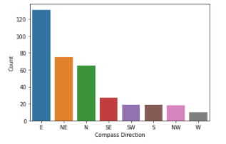

Fig 8 - Summary of Wind Direction Over 2018

In addition to the wind direction, the speed (green), temperature (yellow), pressure (purple), relative humidity (blue), and power capacity (red) were all plotted together. The next figure shows these variables plotted over the entirety of 2018. Power output is proportional to wind speed, as expected based on the equations shown previously. Wind speed appears to be mildly correlated to the temperature and inversely proportional to the relative humidity.

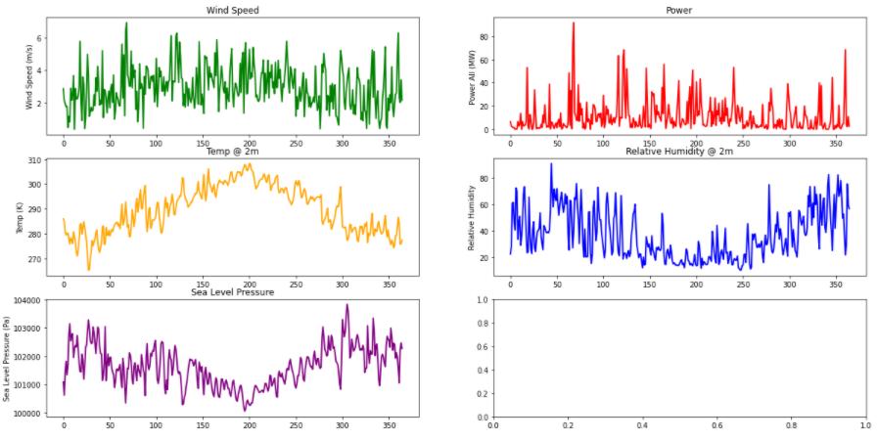

Fig 9 - Wind Speed Time Series for 2018

In order to better assess the relationships, graphs were created for shorter time intervals. The figure below shows the variables of wind speed, temperature, and relative humidity plotted over the months of January and February. Upon closer inspection, there doesn’t appear to be any specific correlation between the temperature and wind speed. Temperature plays a role in wind formation, but surface temperature is more important in the context of its relation to other air masses in the region for wind formation. Therefore without further data, it is hard to say surface temperature alone is an indicator of wind speed.

Relative humidity corresponds to the amount of water vapor in the air, influencing the density of air. The density of air decreases as the relative humidity gets higher. As mentioned in the equation previously, we know that the density of air directly affects the potential power production of a wind turbine. Higher density, aka dry air, will produce more power than lower density moist air. However, after closer inspection it appears there is not a clear trend between the relative humidity and wind speed.

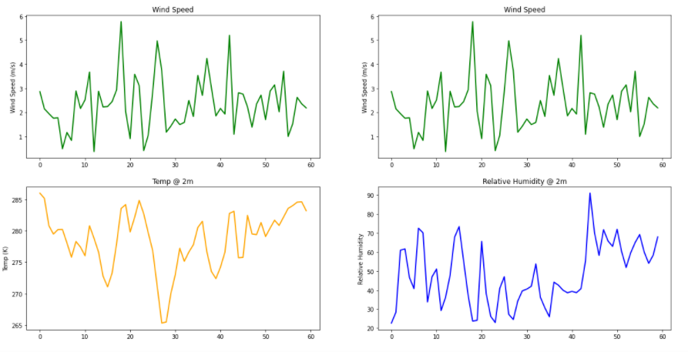

Fig 10 - Comparison of Wind Speed (m/s), Temp (K), and RH for January and February

Afterwards a comparison was conducted between the expected output based on the wind speeds and the total capacity. The output and capacity were used for a single turbine. In the figure below, the red line represents capacity and the blue line represents power output for the wind speed on that day. Looking at the graph, most days are well below capacity.

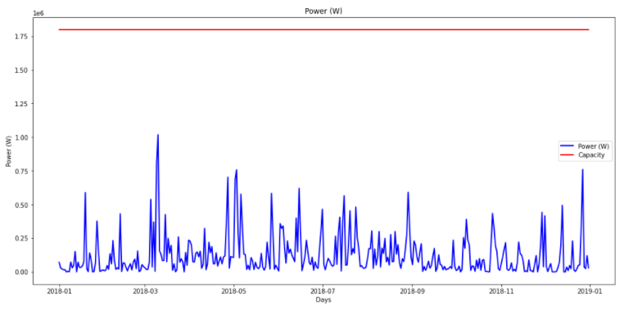

Fig 11 - Turbine Output Relative to Capacity

Creating a distribution of the actual capacity percentage helped put the previous figure in perspective. From the figure below, it is clear to see that the turbines in 2018 were operating at well below capacity. Most of the days were 10% or below.

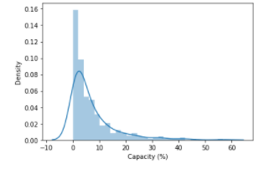

Fig 12 - Distribution Plot of Capacity %

## Conclusion/Future Work

Renewables are growing every year, and need to continue if we are to reach emission goals to curb global warming. Wind energy has been an important part of the solution. The experiment conducted provided a good look into the complexities of predicting power generation from wind farms. This analysis took liberties with many assumptions, such as distributing wind values from a point measurement across the entire wind farm. In order to achieve better results, more complex wind models can be used to get the speeds and directions at the locations of each turbine. Data can be collected over a longer period of time to better understand historical trends and forecast when production will be high or low in the future.

## 

## Appendix

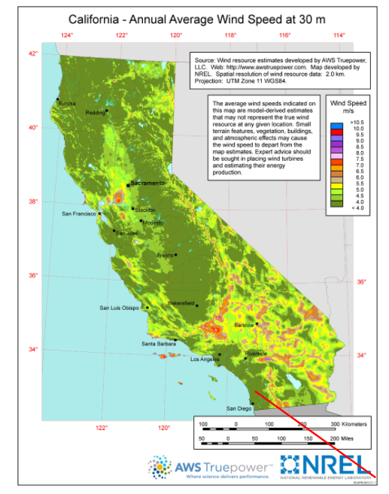

Fig A1 - 2km resolution of California Annual Average Wind Speed at 30m[15]

|  |  |
| --- | --- |
| High Winds Project 2018 (Seawest Energy Group) | |
| Capacity (MW) | 162 |
| Gross MWh | 345,306 |
| Net MWh | 345,306 |

Fig A2 - Summary Power Statistics for High Winds Project

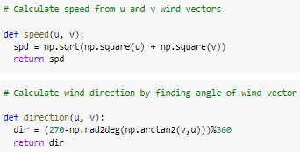

Fig A3 - Wind Speed and Wind Direction Functions

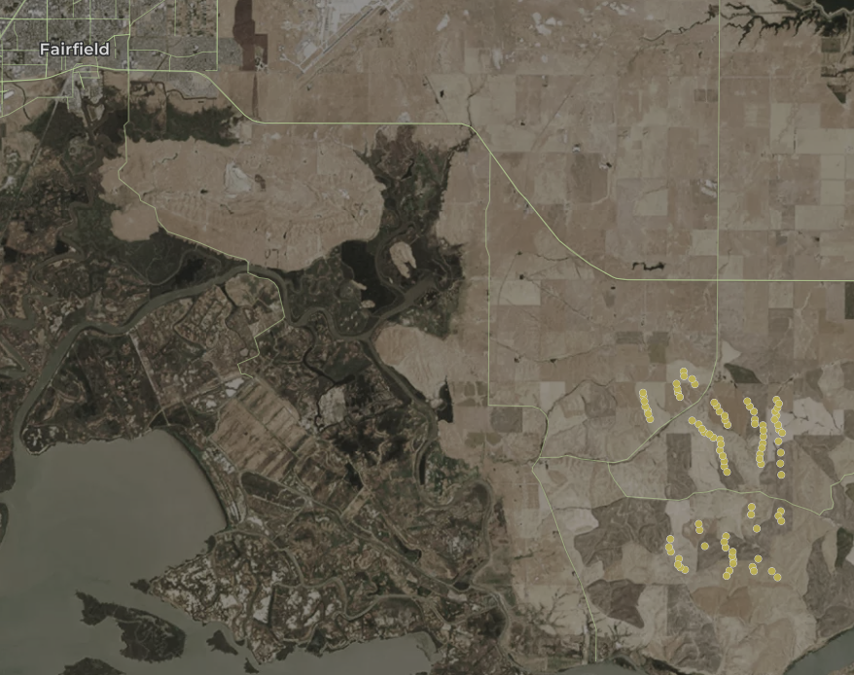

Fig A4 - High Winds Project in Northern CA

1. https://www.epa.gov/ghgemissions/sources-greenhouse-gas-emissions#:~:text=Electricity%20production%20(26.9%20percent%20of,mostly%20coal%20and%20natural%20gas.
2. https://www.awea.org/wind-101/basics-of-wind-energy
3. https://www.energy.gov/articles/how-wind-turbine-works#:~:text=Wind%20turbines%20operate%20on%20a,a%20generator%20to%20create%20electricity.&text=In%20the%20United%20States%2C%20wind%20turbines%20are%20becoming%20a%20common%20sight.
4. https://www.energy.gov/articles/how-wind-turbine-works#:~:text=Wind%20turbines%20operate%20on%20a,a%20generator%20to%20create%20electricity.& text=In%20the%20United%20States%2C%20wind%20turbines%20are%20becoming%20a%20common%20sight.
5. https://ieeexplore.ieee.org/document/8301377
6. M. M., Yagoub. (2010). Application of Remote Sensing and GIS for Renewable Energy: Case of Wind Energy in UAE. International Journal of GeoInformatics. 6. 13-21.
7. California Energy Commission, Energy Almanac, Total System Electric Generation (2018). (See https://www.energy.ca.gov/data-reports/energy-almanac/california-electricity-data/2018-total-system-electric-generation.)
8. https://eerscmap.usgs.gov/uswtdb/
9. https://ww2.energy.ca.gov/almanac/renewables_data/wind/index_cms.php
10. https://www.ncdc.noaa.gov/data-access/model-data/model-datasets/global-forcast-system-gfs
11. https://github.com/blaylockbk/Ute_WRF/blob/master/functions/wind_calcs.py
12. Khalid M., Savkin A.V. (2011) Direction Dependent Power Curves for Wind Power Prediction: A Case Study. In: Howlett R.J., Jain L.C., Lee S.H. (eds) Sustainability in Energy and Buildings. Smart Innovation, Systems and Technologies, vol 7. Springer, Berlin, Heidelberg. https://doi.org/10.1007/978-3-642-17387-5_13
13. https://www.engineeringtoolbox.com/wind-shear-d_1215.html
14. Smith, C., Hatchett, B., & Kaplan, M. (2018). A Surface Observation Based Climatology of Diablo-LikeWinds in California’s Wine Country and Western Sierra Nevada. Fire, 1(2), 25. MDPI AG. Retrieved from http://dx.doi.org/10.3390/fire1020025
15. https://windexchange.energy.gov/maps-data/145